



**Invitation to the International Summer Camp**

**“BIKING, rafting AND SIGHTSEEING IN CZECHIA”**

**22nd July – 5th August 2023**

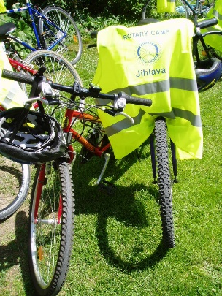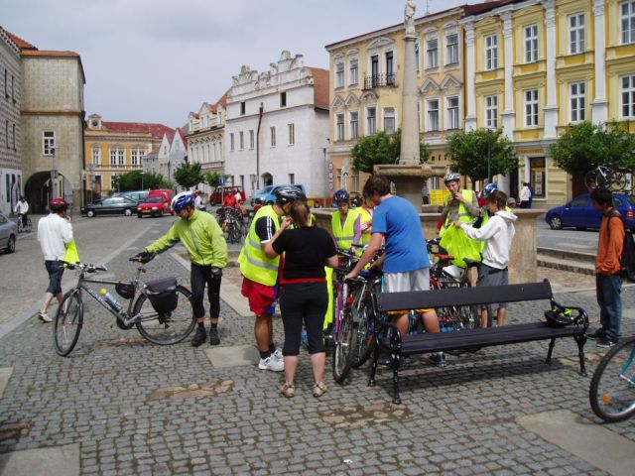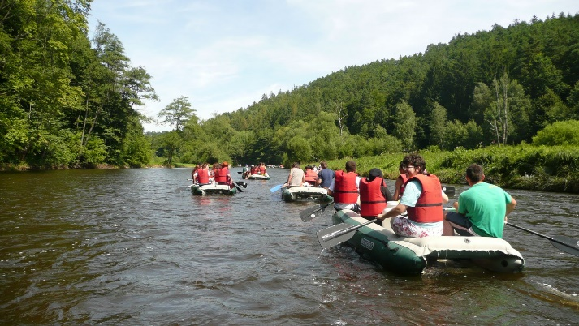

**Host Country / Club:** Czechia - RC Jihlava, RC Ceske Budejovice,

Austria – RC Freistadt

**Participants:** 16

**Age:** 16 – 18

**Language:** English

**Accommodation:** Hotel – Pension, hostels, tents

**Cost:** 100€, flight tickets to arrival point and back, insurance & pocket

money

**Arrival:**  22nd July 2023, Prague, Václav Havel Airport

**Departure:** 5th August 2023, Prague, Václav Havel Airport

Arrivals and departures are allowed only on these days.

**Insurance:** Participants must be insured against illness, accident

and third party damages according to Rotary International

Requirements (suggested CISI Bolduc, Plan „B“, one month)

**All Applications & Registr.:** Applications forms, pages 3 – 7, Supplementary Page B, to be

sent as a color PDF file before April 30, 2023

to Mr. Schmidt and copied (cc) to Mr. Bilek.

**Mr. Jan Bílek Mr. Žiga Schmidt (?)**

***Cell:*** +420 602 204 446 ***Cell:*** +421 910 919 8312

***E-mail:*** jan.bilek@rye2240.org ***E-mail:*** ziga.schmidt@rye2240.org

**Club contacts:**

**RC Jihlava - Mr. Jan Kratky RC Ceske Budejovice - Mr. Jiri Bruha**

***Cell:***+420 607 082 010 ***Cell:*** +420 602 424 594

***E-mail:* kra**tky_jan@centrum.cz ***E-mail:*** bruha@bkarchitekti.cz

**Program:**

First week - biking through forest pathways and country roads, sightseeing, visits of historic

monuments of the region, different kind of sporting and cultural activities – for example visit of

local theatre and familiarization with its function and facilities or visit of blacksmiths workshop

with demonstration of arts and crafts.

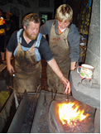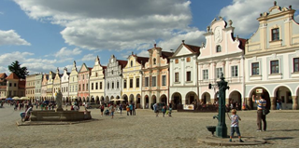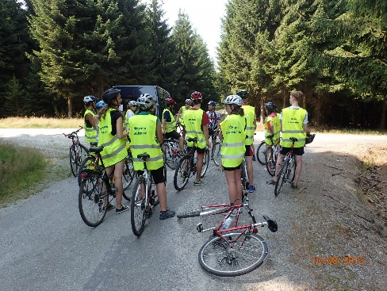

Second week – rafting tour on Vltava river. Vltava river snakes its way from the forest of South Bohemia through Prague, its meanders and natural surroundings are breathtaking. Participants will discover its beauties while rafting. Nature, sport activity and fun, all in one!

During the second week you will also visit a lot of historical monuments (monastery, castles). One day you will spend in Austria – city of Freistadt. At the end of your stay you will move to Prague where you will have 1 - 2 days to enjoy this famous and beautiful city – capital of Czechia.

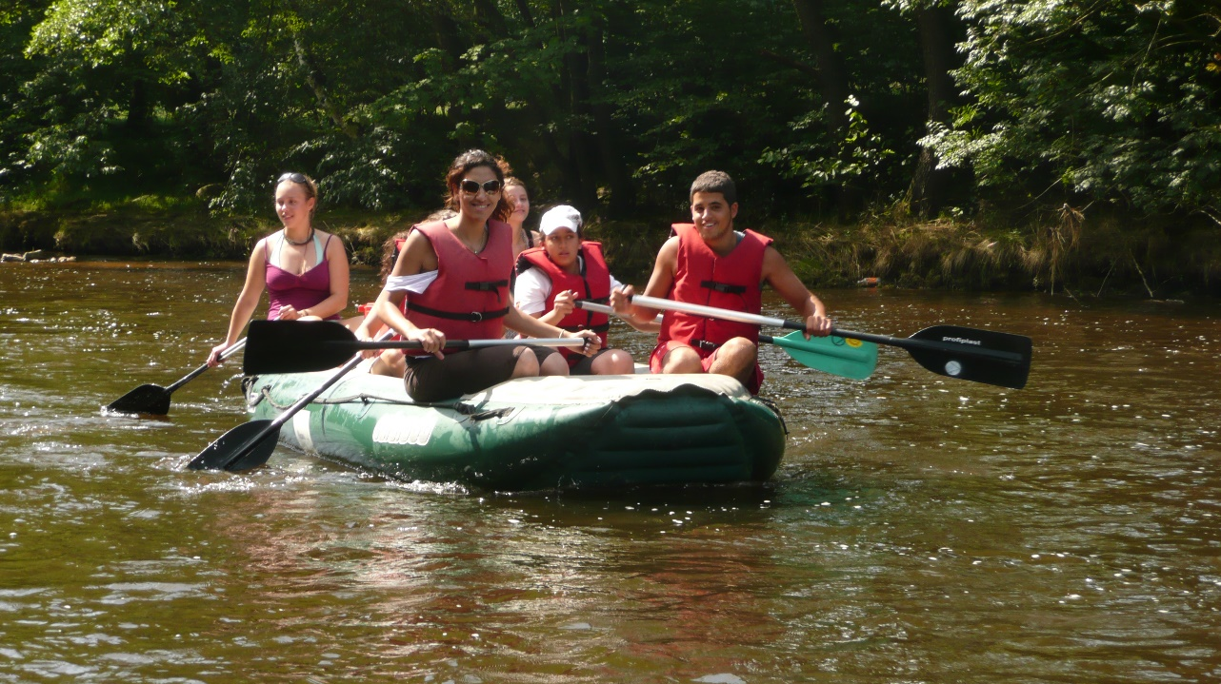

NECESSARY ABILITIES OF EVERY PARTICIPANT:

Ability to bike 40 km on mountain bike daily in a hilly terrain.

Ability to swim – important for rafting

Detailed program will be sent to each participant in May 2023.